

Robert B. Aardema
Aardema, Whitelaw & Sears-Ewald, PLLC
5360 Cascade Road
Grand Rapids, MI 49546

Re: Hurley v. Lakeland, et al
Invoice No. 132233

Dear Mr.Aardema:

I have been unable to reach you by telephone regarding your past due account in the amount of $ 112.00 that is 50 days past due, in the above referenced case. We have made numerous attempts to collect for services rendered. To date, we have not received payment. We pride ourselves in providing you with prompt delivery, and as a professional courtesy, we appreciate timely payment.

We will anticipate payment by return mail. If you have any questions, please do not hesitate to contact me.

Sincerely,
Axiom Requisition Copy Service
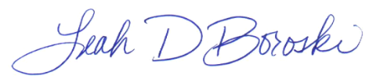

Leah D. Boroski
Collection Manager

